- Match/Merge Set up

To configure Match/Merge set up for the Customer Base Object, following steps need to be done:
  - Create match path with ADDRESS table
  - Create match columns
  - Create match rule set
  - Create match rules

For the Address Base Object, the match columns will be:
Address Line1 (Exact), Address Line 2 (Exact Null matches NOT NULL), State (Exact), City (Exact) and ZIP_CD (EXACT).

No match merge is required for the lookup table.

For the Customer Base Object

- Create match path with ADDRESS table

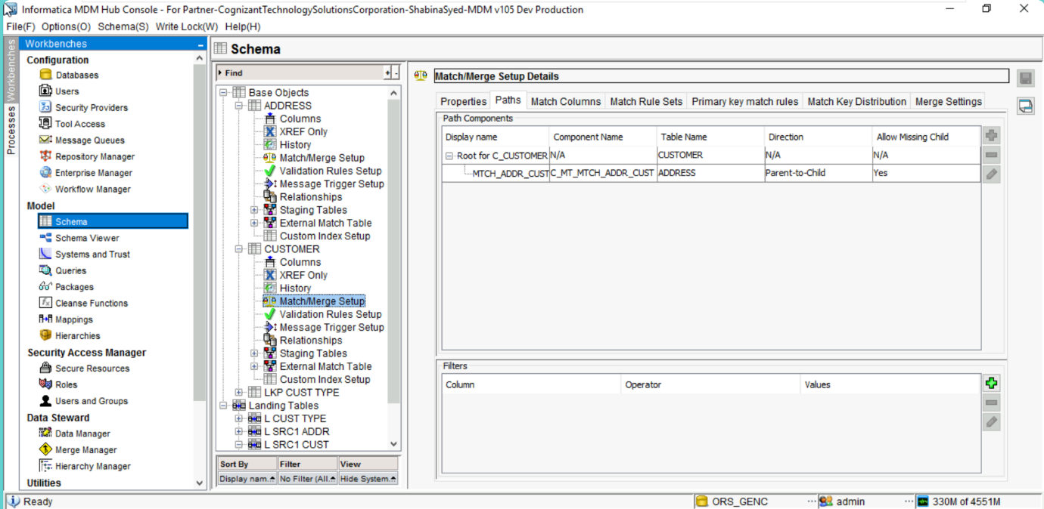
B. Create match columns
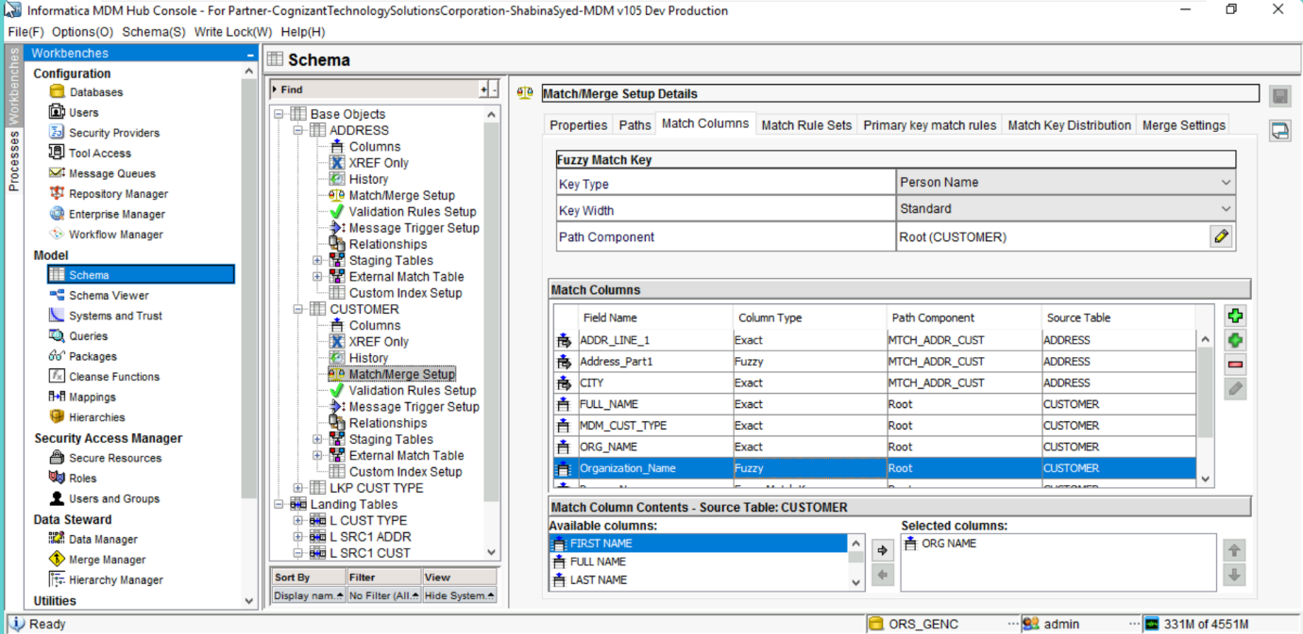
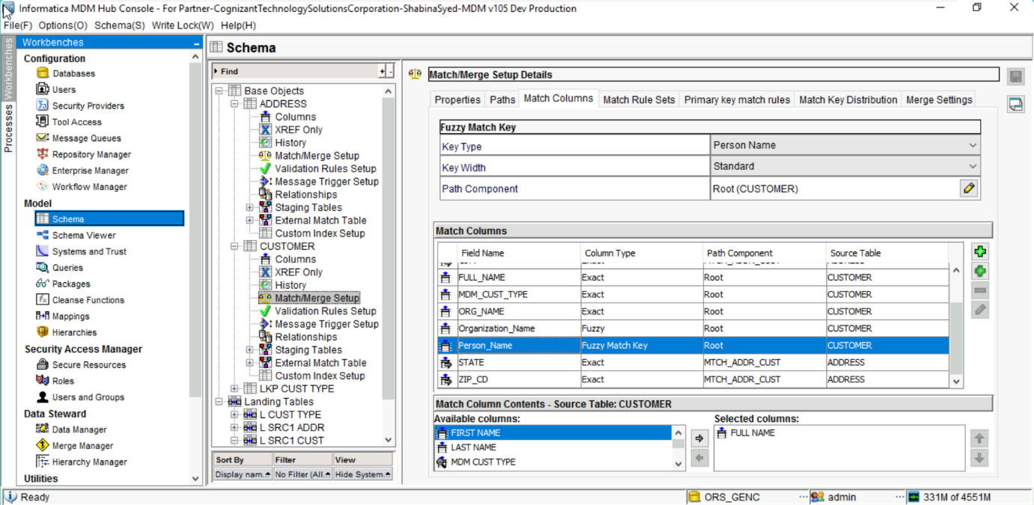
C.Create match rule set
D.Create match rules

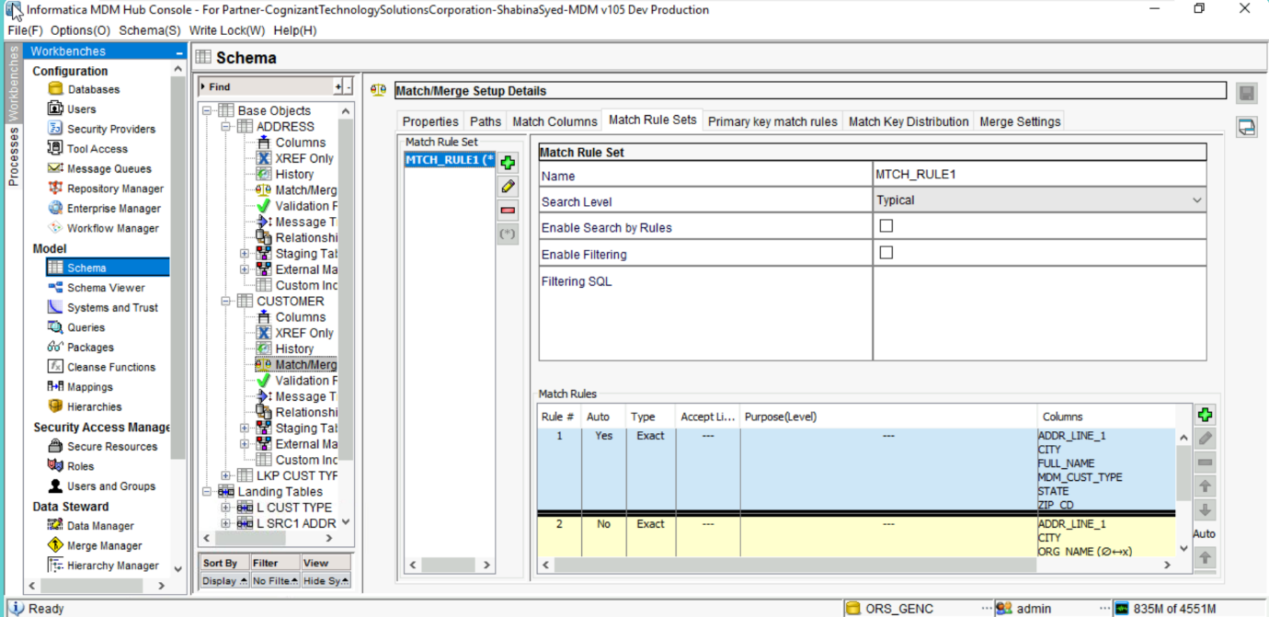
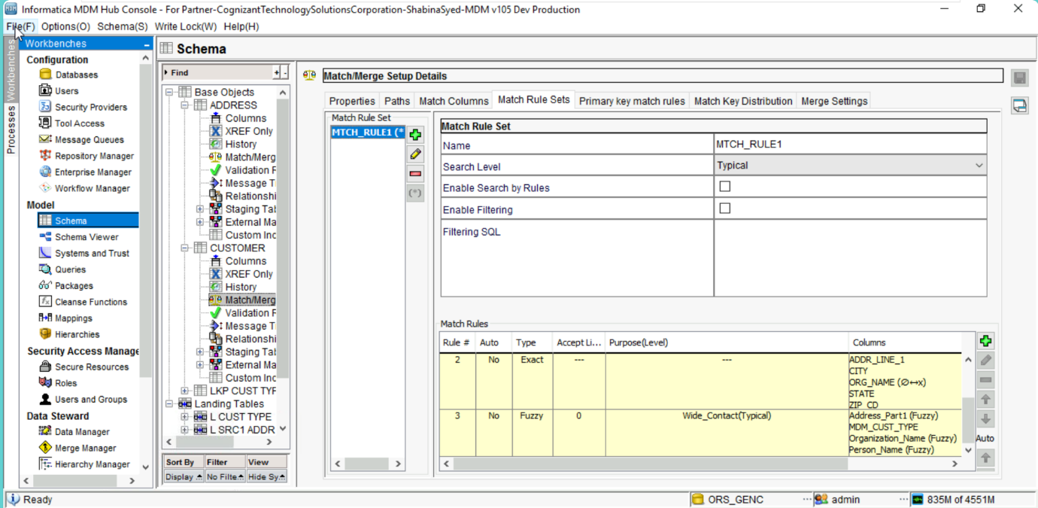
For the Address Base Object
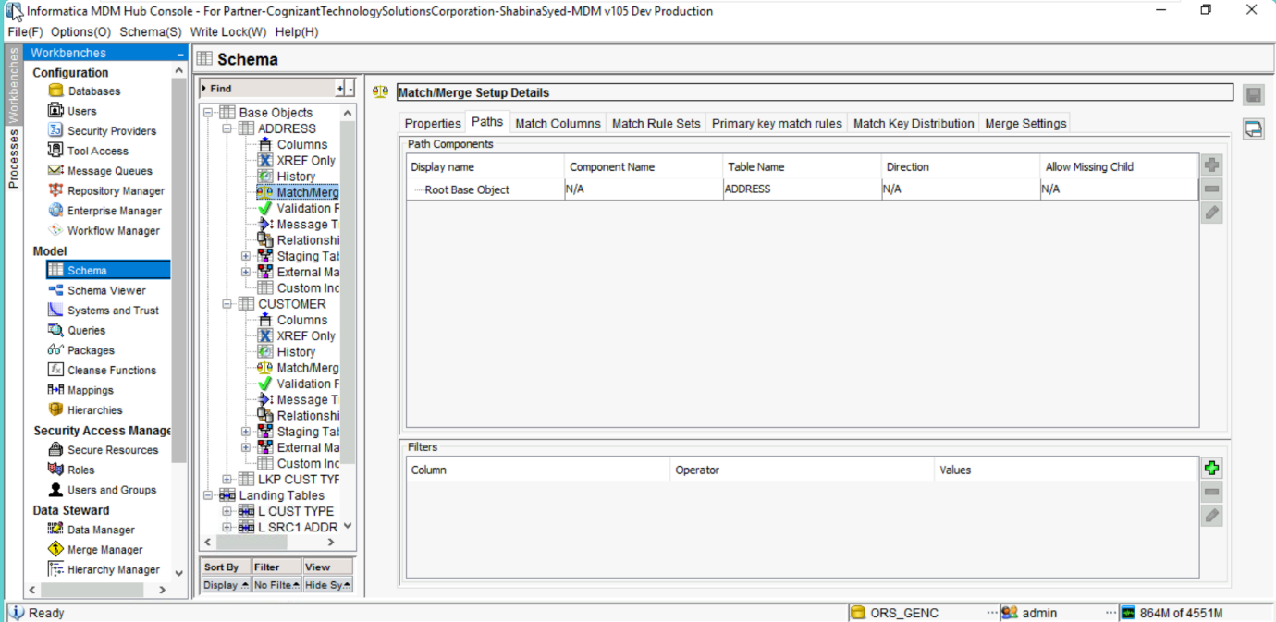

B. Create match columns

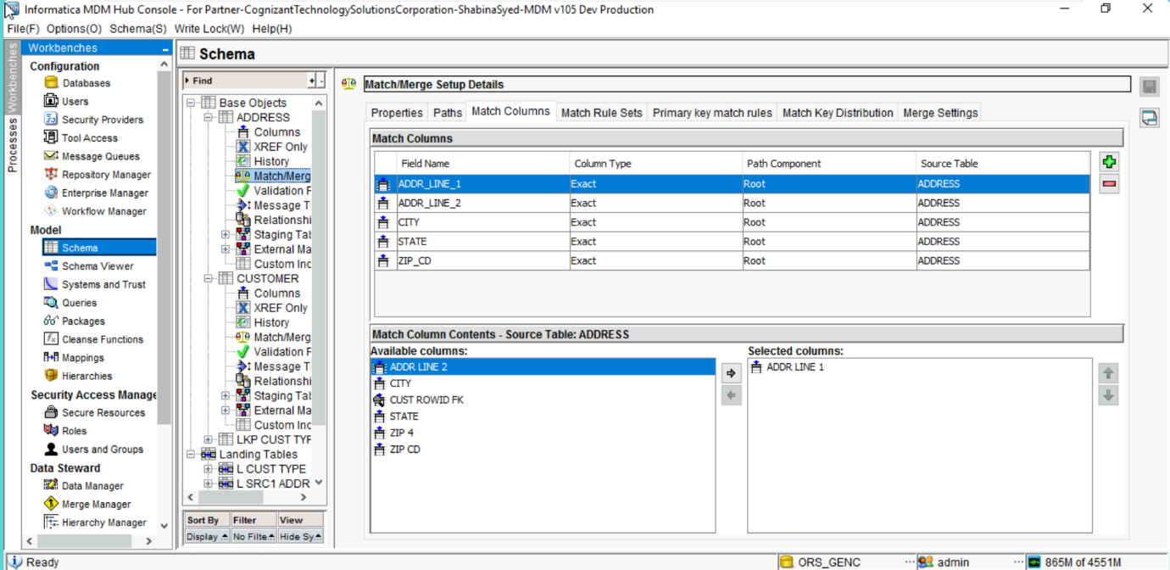
C.Create match rule set
D.Create match rules

